Parallel Port Plug-in Documentation

Version 1.0.0.1 by Sven Gijsen

Introduction

The Hardware communicator program can be used for different purposes. It started as a program that could fully control (read/write) the parallel port (LPT). By this it was possible to debug/analyze the LPT port which is used on the Stimulation PC for capturing the Scanners Trigger, responses from the Button Boxes and to generate TMS pulses. The program can not only read/capture data but can also write/generate data which makes it suitable as a simulation device. The program is also extended with some features that make it possible for the user to change the Ports Mode and to log the data.

HOWTO External triggering (Simulating the scanner Tr pulse and response buttons)

To check whether your E-prime/Presentation/StimuliDX/etc.. script file works correctly with the MRI lab hardware (trigger pulses from the scanner and the response boxes), you can use this HOWTO as a guideline to setup external simulation triggering. This external simulation triggering gives you the main advantage that you don not need the MRI scanner and the response buttons to generate the Tr/trigger pulses and button boxes to test your stimuli file. A simulating device (TBV PC) can use the software to generate/simulate the signals. To setup this external triggering you first need to connect the simulating device (TBV PC) to the response reading/Stimuli device (Stimuli PC). This is done by turning a switch in “External Response Mode”. A special modified LPT cable (already present) is then switched between the Stimuli and TBV PC. This Howto explains all functionality of the “LPT Analyser” software. Finally, an example of a typical setting/configuration on how to use the TBV PC as an external response device for the stimulus PC is explained.

To understand how the “LPT analyzer” program works and to gain some background knowledge you can read the following explanation:
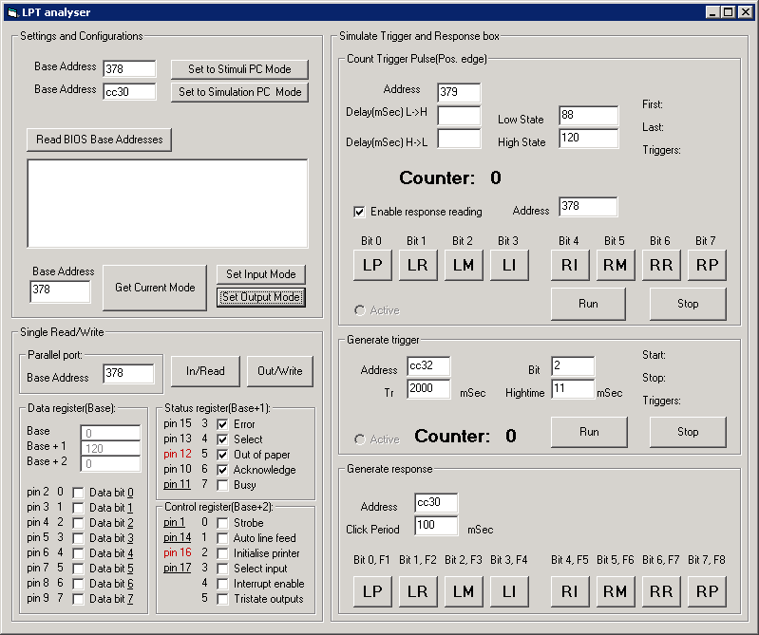
2
3
4
5
6
1
7
1/2: Settings and configurations. If you press “Read Bios Base Addresses” then the program reads the BIOS memory space that specifies which ports are presently installed on the PC and at which address the corresponding Base Address is at. Please note that not all LPT ports are declared in this BIOS memory space, some manufacturers use the windows registry to store the address. After pressing “Get Current Mode” the program reads the LPT mode of the Base Address specified in the textbox (this value should be hexadecimal!). With “Set Input Mode” you can force the specified port to go in input mode. In this mode you can use the Data register to read external signals. Please note that not all ports are compatible with this mode. With “Set Output Mode” you can force the specified port to go in output mode. In this mode you can switch the output state of the Data register.
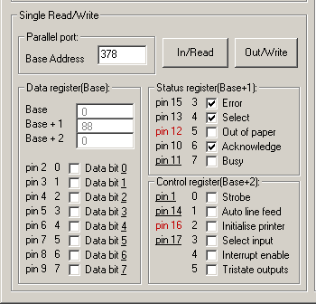
3
3: Single Read/Write. After you pressed the “In/Read” button the program reads the state of each bit of each register of the specified LPT port with base address as specified in the “Base Address” textbox.
  - The “Base” textbox shows the decimal value that was read from the Data register that is located at the “Base Address” specified in the textbox.
  - The “Base + 1” textbox shows the decimal value that was read from the Status register that is located at the “Base Address” specified in the textbox plus one. This port is read only.
  - The “Base + 2” textbox shows the decimal value that was read from the Control register that is located at the “Base Address” specified in the textbox plus two.
  - The checkboxes change to the corresponding decimal bit value of the register. Please note that underlined means that the corresponding bit is hardware inverted.
  - The center row represents the bit corresponding to the pin numbering of a 25 Pin D-Sub Connector.
  - The two Red pins represent the two lines that are crossed to make the communication between the Stimulus and the TBV PC possible.
When you press the “Out/write” button the program writes the value of each bit of the checkboxes to each register of the specified LPT port with base address as specified in the “Base Address” textbox. Please note that the Status port is read only and therefore cannot be written to.
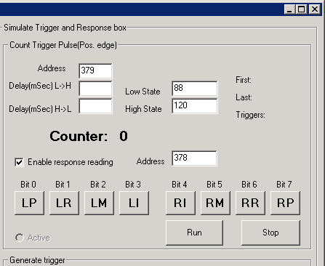
4
4: Count Trigger Pulse. With this part of the software you can Read/Count pulses from a register of an LPT port that is specified at the register address “address”. The program first needs to know at which decimal value of the defined register (8 bits) the puls is in a “low”/non counting state, you should specify that decimal value in the “Low State” textbox. Secondly you need to specify the “High State” decimal value. If the program detects a decimal value change of the byte from the specified register going from the Low to the High state the “Counter” label is incremented with 1. Because standard not all bits from the specified register are active low it can be that Low state does not equal 0. The difference between Low and High state (for example 120-88 = 32) determines which bit changes are detected (→ 32 decimal = 00100000 binary → = bit 5). The automatic trigger counting procedure is started/enabled after you pressed the “Run” button. The “Active” radio button is checked when the procedure has started. “First”/”Last” shows the time the first/last pulse was read. “Triggers” represents the number of times a pulse was recieved. The procedure keeps running till you press the “Stop” button. You can also generate Trigger pulses (see 5:) with this program but these two processes cannot be simultaneously active at the same time. You can also enter a value in the “Delay(mSec)” textboxes. This makes sure that the program waits and does nothing for the specified time after the puls going from Low to High (L→H) or High to Low (H→L). This feature can be used as a solution for switch de-bouncing. You probably need to enter a value here if the device which generates the pulses is a common hardware switch.
After checking the “Enable Response Reading” checkbox each bit of the byte specified at the “address” register is read. For each bit there’s a corresponding button which will change to a blue color if the corresponding bit has a low value (connected to ground). This feature is implemented to be able to see the button responses of an external device like the button boxes. The caption of the button stand for the finger which our button box line is connected to (for example LP = Left Pink, RI = Right Index etc.).
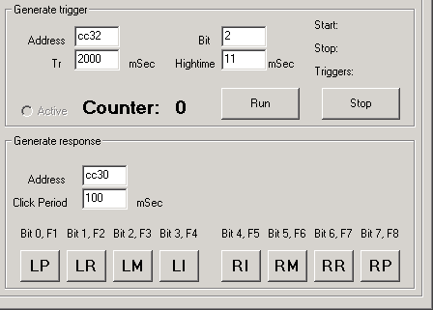
5
6
5: Generate Trigger. With this part of the program you can automatically generate trigger pulses. You first need to specify at which “Bit” (start counting at 0) of a register “Address” (hexadecimal) the pulse should be generated. The pulse period time is specified in milliseconds in the “Tr” textbox. The pulse then stays in a high state for the value specified in the “Hightime” textbox. If you press “Run” the procedure immediately starts with the pulse starting at a high value. The “Active” radio button changes to a checked state. You can stop the procedure again by pressing the “Stop” button again. The “Counter” label represents the number of generated pulses and will increment each time after a pulse is generated. “Start”/”Stop” is the start/stop time and “Triggers” is the trigger count.
6: Generate Response. With this part of the program you can generate responses/pulses to simulate for example the button box presses. You first need to enter the “Address” to which 8 bits are connected to. If you click a button then the corresponding bit of the register will go to a high value and stay high for the value in milliseconds that you entered at the “Click Period” textbox. You could alternatively press F1…F8 to enable the corresponding bit. If you use the keyboard then the bit stays high until you release the corresponding key. You can then also press multiple keys simultaneously. The button color will change to a blue color if you press the corresponding key (F1…F8).

Example of setting/configuring the TBV PC as an external response device for the stimulus PC.

- Startup the TBV and the stimulus PC.
- Turn/leave the switch (found on the first shelf) to “Default Response Mode”.
- Stimulus PC: Open LPT Analyser ("E:\Sven\LPT Analyser\LPT Analyser.exe") or use the desktop icon.
- Stimulus PC: Press “Set to Stimuli PC Mode”
- TBV PC: Open LPT Analyser ("E:\Sven\LPT Analyser\LPT Analyser.exe") or use the desktop icon.
- Turn/change the switch to “External Response Mode”.
  - This disconnects the Scanner trigger pulse and the button signal lines from the Stimulus PC. The Stimuli PC is now directly connected to the TBV PC which can then be used as a Scanner trigger and button box simulating device with the use of this software. Please note that two lines of the cabling between the Stimulus and TBV PC are crossed to make the communication possible.

TBV PC

Stimulus PC
Scanner trigger and Button boxes

Channel A:
Default response mode

Channel B:
External response mode
- TBV PC: Press “Set to Simulation PC Mode”
- Test the communication:
  - TBV PC: Press F1 – F8 to generate the button responses. The corresponding buttons at the Stimuli PC should now light up in blue.
  - TBV PC: Press RUN to generate a trigger; Stimulus PC: Press RUN to count trigger pulses. Each time the TBV PC now generates a trigger pulse the Stimulus PC increments the trigger counter.
- If the communication has succeeded then the TBV PC can be used as a simulating device for the Stimulus PC. The “LPT analyzer” software of the stimulus pc can be closed. You can now test your own (E-prime/Presentation/StimuliDX) script file with the TBV PC as the simulating device.
Don’t forget to turn the switch back in ”Default Response Mode”!!!

